Installation steps in VS Code

- Install VS Code
- Install Node.js from
- Go to https://nodejs.org
- Download the LTS version
- Run the installer, click Next → Next → Install
- To verify: Open Command Prompt and type node --version - you should see a version number.
- Type npm --version (to verify npm is also installed)
- Create a project folder
- Make a new folder anywhere, like C:\PlaywrightLearning
- Open this folder in VS Code (File → Open Folder)
- Open VS Code Terminal
- In VS Code, press Ctrl + ` (backtick key) or go to Terminal → New Terminal
- To Install Playwright Type this command in the terminal:
npm init playwright@latest
- Answer the setup questions:
- Where to put tests? Press Enter (accepts default)
- Add GitHub Actions? Type n and press Enter (If you want to add GitHub Actions just press Enter. Since the default is Y
- Install browsers? Type y and press Enter (this downloads Chrome, Firefox, Safari engines)
That's it! Playwright will install everything you need.
- After installation go to VS CodeHelpAbout, you could see the following screen.

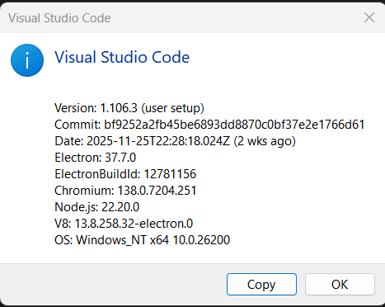

How to install planner, generator, healer – in playwright
- Planner = plans your test strategy
- Generator = writes the actual test code
- Healer = fixes broken tests

Installation Steps:

Step 1: Install the Chatmodes package
In your VS Code terminal, type:
npm install -D @playwright/chatmodes

Step 2: Verify installation
After installation completes, you should see a chatmodes folder appear in your project.

Step 3: Check the files are there
Look in your Explorer panel for:
- 📝 planner.chatmode.md
- 📝 generator.chatmode.md
- 📝 healer.chatmode.md

Step 4: Using them
These files work with AI chat features in Playwright. You'll use them by opening the Playwright panel and interacting with the AI assistant for test creation.

Running Tests
Terminal commands:

  - npx playwright test
# Run all tests (headless)
  - npx playwright test --headed
# See browser while testing
  - npx playwright test example.spec.ts
# Run specific file
  - npx playwright test --debug
# Step through test line-by-line

Debugging Tips
- Codegen (record your actions): npx playwright codegen example.com
- opens browser, records what you click/type, generates code
- Show report: npx playwright show-report
- see which tests passed/failed with screenshots

